TRANS EUROPEAN POLICY STUDIES ASSOCIATION
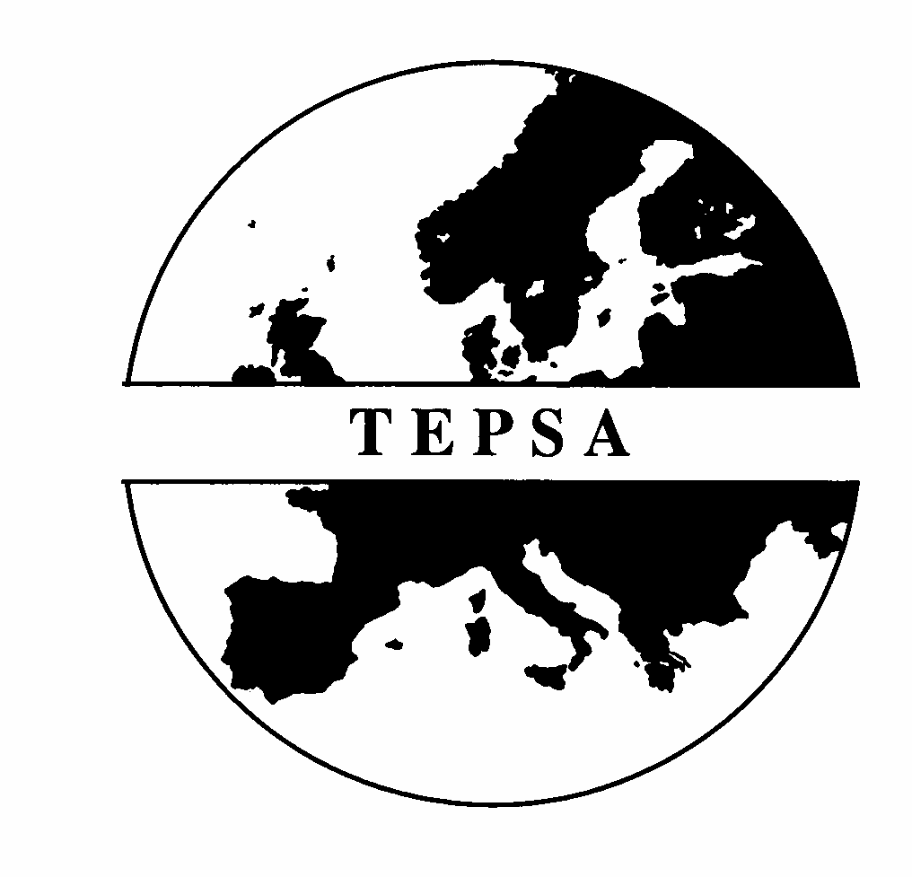

50th anniversary of the Treaty of Rome

Declaration

On 25th March 2007 we mark the 50th anniversary of the signature of the Treaty that played a key role in the process of European integration, beginning with the European Communities and leading to today’s European Union.

For TEPSA and its members it is an occasion to reflect on the past and also on the Union’s situation and prospects in the 21st century.

The results of the Treaty of Rome have been extraordinary. European integration has proved so effective and attractive that in 50 years it has tripled its population and quadrupled the number of its member states.

In the 1950s, only a few visionaries believed that the Treaty could lead to:
- the progressive integration of the economies of Europe’s states;
- the development of a system for common political decisions in the interests of Europe’s peoples;
- the peaceful reunification of the East and West of Europe’s continent.
These dreams of the EU’s founding fathers have now been realised.

After the conflict and disorder of Europe’s wars in the first half of the 20th century, the EU’s development has coincided with the longest period of peace that Europe’s people have ever known. Its institutional framework has helped to reconcile many of their historical problems, and allowed the member states – big and small – to cooperate in a non-hegemonic system of governance. This process has accompanied the greatest increase in social and economic welfare that Europe has ever experienced, with the development of a single market of nearly 500 million people, and the creation of a single currency, the euro.

The existence of today’s Europe – united, free, and at peace with itself – is an achievement that deserves to be celebrated by Europe’s citizens and by its partners. Throughout the world it is seen as the most successful model of regional integration.

But the new generation, which has never known war in Europe, has more expectations. It wants the EU to provide a framework in which:

- The benefits of economic prosperity can be shared in a way that corresponds to European concepts of social justice
- Solutions can be found to common problems that cannot be handled at national level: that means challenges of the environment, problems of transnational crime and terrorism, migration, energy, and many others
- Europe’s voice can be heard in world affairs for the defence of European interests and the projection of European values - in conflict resolution, peace-keeping, aid for development, and human rights

To fulfil these aims, the EU needs to pursue its institutional and constitutional development, providing for effective decision-making at the supranational level while respecting the principle of subsidiarity. The Constitutional Treaty signed by all member states offered necessary reforms in the functioning and democratic legitimacy of the EU. Our leaders must find a way ahead to ensure that those improvements can be realised.

The EU’s process of deepening has often gone hand in hand with its widening to include new members, strengthening its unity and European values. In due course it will welcome other European countries that fully satisfy the conditions for membership.

Today we reflect on the past and look to the future. We cannot predict what will be the state of the European Union in 50 years from now. But we resolve to support the continuing development of European integration in ways that contribute to our common ideals of liberty and democracy.

This declaration was prepared by the Board of TEPSA with the support of members

What is TEPSA?
The Trans European Policy Association is an independent research network established 33 years ago in 1974. For many years it has contributed to the development of political thought at the European and national level. Its network of scholars and practitioners continues to stimulate ideas and to comment critically on political, economic and social questions.

The TEPSA network is composed of 27 institutions and organisations specialising in European and international affairs, located in most of the EU Member States. As a partner in shaping European civil society, it promotes transnational exchange and deliberation on Europe’s future, and serves as an engine for the creation of a European research area. Further information on its activities can be found at http://www.tepsa.be

19 March 2007

